

PROJECT REPORT

**SONAR SIGNAL PROCESSING IN GAUSSIAN ENVIRONMENT**

COURSE CODE: ECE2006

COURSE: DIGITAL SIGNAL PROCESSING

SLOT: L11 + L12

FACULTY: SHARMILA N

PROJECT MEMBERS:

* KARTHIKEYAN B M (20BEC0503)
* YOGESHWAR P (20BEC0606)
* KANISHKA RITHU D (20BEC0730)

**ABSTRACT:**

The sonar has played a crucial role in developing ocean resources and marine target detection. The virtual battlefield is a successful case of virtual reality technology in the military field. Acoustic warfare is an important method to modern underwater warfare. Digital signal processing is used to extract features from the signal. Gaussian noise is a statistical noise having probability density equal to the normal distribution function. UKF algorithms are used to evaluate tracking in Gaussian and non-Gaussian noises.

**INTRODUCTION:**

**ACTIVE SONAR**

A sound pulse known as a "ping" is produced by active sonar, which then listens for the pulse's reflections. The pulse could be a chirp that changes frequency, or it could have a fixed frequency. The receiver compares the frequency of the reflections to the known chirp if there is one. The receiver can obtain the same information as if a much shorter pulse with the same total power had been transmitted thanks to the resulting processing gain. Long-range active sonar often employs lower frequencies. Anti-submarine technology known as active sonar fires an extremely loud pulse into the water and then listens for the echoes to follow the target within the range.

**PASSIVE SONAR**

Sonar that is passive only listens, never transmits. Most of them are military, though some are scientific. Large sonic databases are typical for passive sonar systems. These databases are routinely used by computers to distinguish between different ship classes, activities (such as ship speed or weapon type released), and even specific ships. The environment, the receiving equipment, the sending equipment in active sonar, and the target radiated noise in passive sonar all affect how well sonar detects, classifies, and locates objects.

**METHODOLOGY:**

**BANDPASS FILTER:**

A band-pass filter is a device that passes frequencies within a certain range and rejects (attenuates) frequencies outside that range. A band pass signal is a signal containing a band of frequencies away from zero frequency, such as a signal that comes out of a bandpass filter. An ideal bandpass filter would have a completely flat passband and would completely attenuate all frequencies outside the passband. Additionally, the transition out of the passband would be instantaneous in frequency.

**CROSS-CORRELATION:**

There are also many applications of signal cross-correlation in signal processing systems, especially when the signal is corrupted by another undesirable signal (noise) so that the signal estimation (detection) from a noisy signal has to be performed. Signal cross correlation can be also considered as a measure of similarity of two signals.

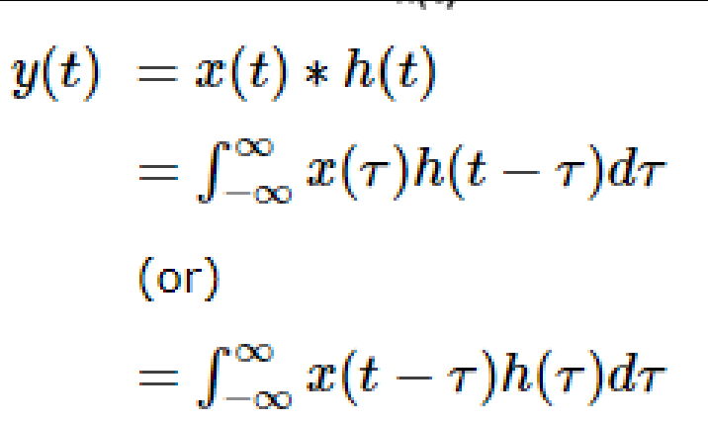

**BLOCK DIAGRAM**

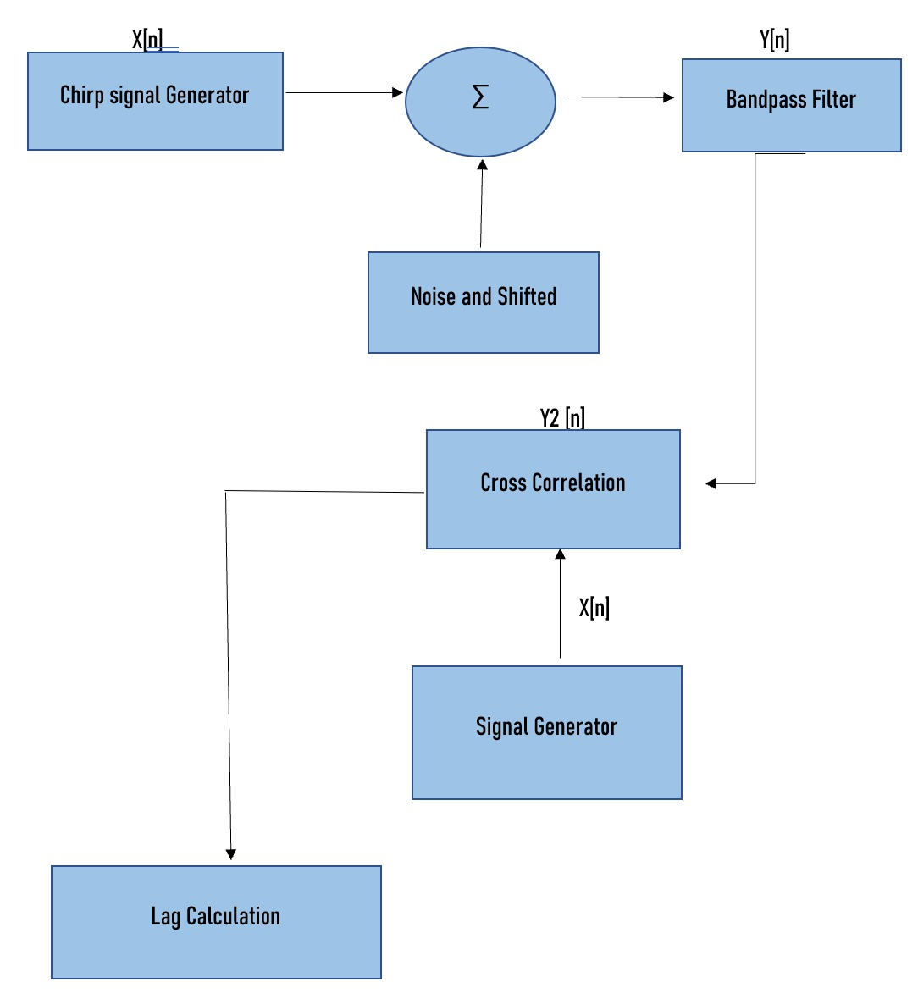

**STEPS INVOLVED IN SONAR SIGNAL PROCESSING:**

1. **CHIRP PULSE CREATION:**

Chirp Signal is a Frequency Modulated non-stationary signal. A chirp signal is one that sweeps linearly from a low to a high frequency. Linear and Logarithmic modes generate a swept frequency cosine with instantaneous frequency values specified by the frequency and time parameters.

Create a chirp signal of the form: v_tx(t)=rect(t/T) cos( 2pi[f0+0.5Kt^2) with the following parameters:

T=5 ms. Delta f= 4kHz,f0 = 10kHz ,K= Δf/T Hz / s

1. **POINT TARGET SIMULATION:**

Simulate one return (or more) from a point target located at a range of about 1.5m <R1<2.5m from the transducer.

td1= 2R1/ c //two way delay to target.

A1=1/R1^2

v_rx=A1cos(2pi(f0 (t-td-td1) +0.5K(t-td-td1)^2).

rect ( (t-td -td1)/T) The return echo is formed by delaying the transmitted pulse by an additional amount td1 and scaling the amplitude by a factor proportional to 1/R1^2.

1. **MATCHED FILTER:**

In [signal processing](https://en.wikipedia.org/wiki/Signal_processing), a matched filter is obtained by [correlating](https://en.wikipedia.org/wiki/Cross-correlation) a known delayed [signal](https://en.wikipedia.org/wiki/Signal_(electrical_engineering)), or template, with an unknown signal to detect the presence of the template in the unknown signal. This is equivalent to [convolving](https://en.wikipedia.org/wiki/Convolution) the unknown signal with a [conjugated](https://en.wikipedia.org/wiki/Complex_conjugate) time-reversed version of the template. The matched filter is the optimal [linear filter](https://en.wikipedia.org/wiki/Linear_filter) for maximising the [signal- to-noise ratio](https://en.wikipedia.org/wiki/Signal-to-noise_ratio) (SNR) in the presence of additive [stochastic](https://en.wikipedia.org/wiki/Stochastic_process) [noise](https://en.wikipedia.org/wiki/Noise_(signal_processing))

We will create a matched filter H(f)= conj(V_ptr(f)) matched to the response v_ptr(t) that would be recorded from a point target. If passband linear system effects are small, then v_ptr(t)=v_tx(t).Apply the matched filter to the simulated return.

1. **FORMING AN ANALYTICAL SIGNAL**

[The Fourier Transform](https://www.gaussianwaves.com/2015/11/interpreting-fft-results-complex-dft-frequency-bins-and-fftshift/) of a real-valued signal is complex-symmetric*.* It implies that the content at negative frequencies are redundant with respect to the positive frequencies. So,we need to create an analytic signal by removing redundant negative frequency content resulting from the Fourier transform. The analytic signal is complex-valued but its spectrum will be one-sided (only positive frequencies) preserving the spectral content of the original real-valued signal. Using an analytic signal instead of the original real-valued signal, has proven to be useful in many signal processing applications.

We will form the analytic version of the signal by zeroing out the negative frequency components (ie. the second half of the frequency vector), and inverse transform to obtain the analytic signal.

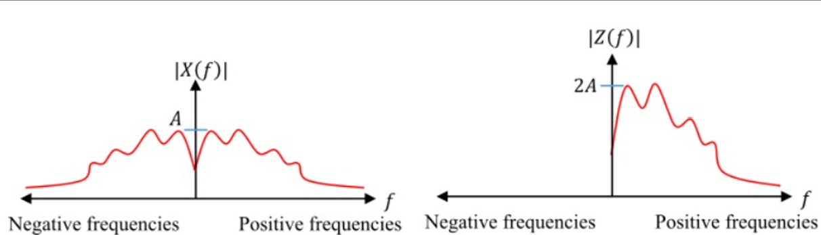

## TRANSLATING THE SIGNAL TO BASEBAND

## A [baseband signal](https://www.sciencedirect.com/topics/engineering/baseband-signal) can be transmitted over a pair of wires (like in a telephone), [coaxial cables](https://www.sciencedirect.com/topics/engineering/coaxial-cable), or [optical fibers](https://www.sciencedirect.com/topics/engineering/optical-fibers). But a baseband signal cannot be transmitted over a radio link or a satellite because this would require a large antenna to radiate the low-frequency spectrum of the signal. Hence the baseband signal spectrum must be shifted to a higher frequency by modulating a carrier with the baseband signal. This can be done by amplitude and by angle modulation (frequency and phase).

## 

## We translate the signal to baseband, by multiplying the time-domain analytic signal by the factor exp(-j*2*pi*10*).Plot the magnitude and phase of the analytic signal.

## ADDING NOISE TO THE SIMULATION

## Generate a vector containing Gaussian noise with standard deviation of say 20% of amplitude of A1.Now we add the noise to the received echo and repeated STEPS 3,4 and 5.

**RESULT:**

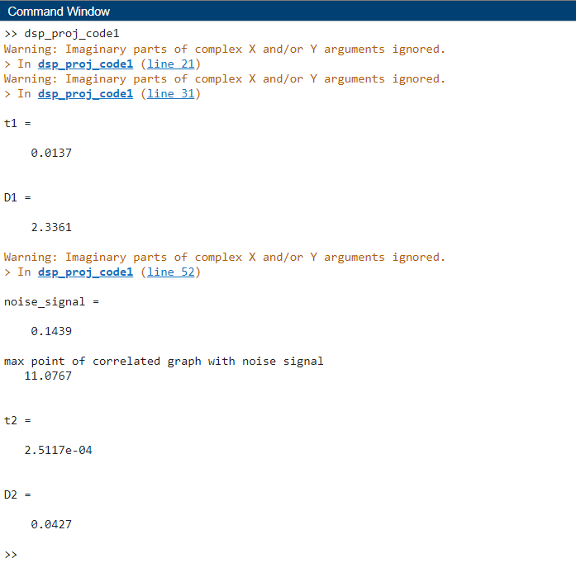

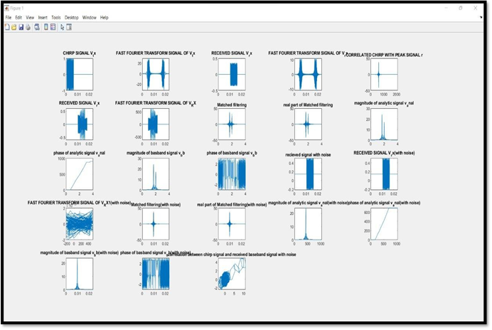

**VALIDATION RESULTS:**

|  |  |  |
| --- | --- | --- |
| **PARAMETER** | **INPUT DISTANCE** | **OBTAINED DISTANCE** |
| **WITHOUT NOISE** | **1.667** | **2.336** |
| **WITH NOISE** | **1.667** | **0.0427** |

**INFERENCE:**

* From the simulation and graphs obtained we can see that the distance which was considered for the transmitted signal without noise by us was 1.667and the distance obtained is 2.33, while, considering the same distance but the signal with noise the distance turns out be 0.0427 which is very less thus increasing the probability of error ,making it difficult to predict the target as the transmitted signal does not even reach the target due to the noise distortions and cannot get the received signal which is reflected back from the target.
* We tried reducing this deviation to as less value as possible considering the signal with and without noise. Thus, the signal without noise gave us the better result with as less deviation as possible. This can be further worked on in future to improve the accuracy of detecting the position of the target

**UNDERWATER TARGET DETECTION WITH AN**

**ACTIVE SONAR SYSTEM**

**METHODOLOGY:**

* Here, we are trying to simulate an active sonar with two targets in an underwater environment. This consists of an isotropic projector array such that its physical values remain same in all directions and a hydrophone element to receive backscattered signals of the wave. The received signals include both direct and multipath contributions.

**Underwater Environment:**

* Multiple propagation paths are present between the sound source and target in a shallow water environment. Define the properties of the underwater environment, including the channel depth, the number of propagation paths, the propagation speed, and the bottom loss.Let us assume three paths in a channel with a depth of 150 meters and a constant sound speed of 1520 m/s and a bottom loss of 0.5 db.
* An underwater acoustic channel to propagate narrowband sound from point to point can be created using the command phased.IsoSpeedUnderwaterPaths.And multipath channel for each target can be created using the command phase. Multipath Channel for the waveform to propagate along the multiple paths.

### Sonar Targets:

* The system has two targets, one is more distant but has a larger target strength, and the second is closer but has a smaller target strength. Both targets are isotropic and stationary with respect to the sonar system. These target positions, along with the channel properties, determine the underwater paths along which the signals propagate.
* Plotting the paths between the sonar system and each target such that z-coordinate determines depth, with zero corresponding to the top surface of the channel, and the distance in the x- y plane is plotted as the range between the source and target.

### Transmitter and Receiver:

* Now, to transmit the signal to targets, create a rectangular waveform and define the maximum target range and range resolution for the waveform. Update the sample rate of the multipath channel with the transmitted waveform sample rate. The transmitter consists of a hemispherical array of back- baffled isotropic projector elements, creating this array and viewing the geometry.
* Then comes the receiver part which consists of a hydrophone and amplifier. The hydrophone is a single isotropic element and has a frequency range from 0 to 30 kHz, which contains the operating frequency of the multipath channel.

**Receiver Radiator and Collector:**

* Let,the hydrophone voltage sensitivity be-140 dB.The received signal also consists of thermal noise. Assume that the receiver has 20 dB of gain and a noise figure of 10 dB. In an active sonar system, an acoustic wave is propagated to the target, scattered by the target, and received by a hydrophone.
* Next, is the sonar system simulation where we transmit the rectangular waveform over 10 intervals and then simulate the signal at hydrophone for each transmission. Plot the magnitude of non-coherent integration of the received signals to locate the returns of the two targets. The target return is the superposition of pulses from multiple propagation paths, resulting in multiple peaks for each target. Bellhop can generate acoustic paths for spatially- varying sound speed profiles. Simulate transmission between an isotropic projector and isotropic hydrophone in a target-free environment with the 'Munk' sound speed profile.

**Active Sonar with Bellhop:**

* The path information is contained in a Bellhop arrival file (MunkB_eigenray_Arr.arr). Let us consider the channel is 5000 metres in depth. The source is located at a depth of 1000 metres and the receiver is located at a depth of 800 metres. They are separated by 100 kilometres in range. Import and plot the paths computed by Bellhop. Create a new channel and receiver to use with data from Bellhop and specify a pulse and simulate the transmission of ten pulses from transmitter to receiver. Plot the non-coherent integration of the pulses and conclude the inference after performing the simulations.

**RESULTS:**



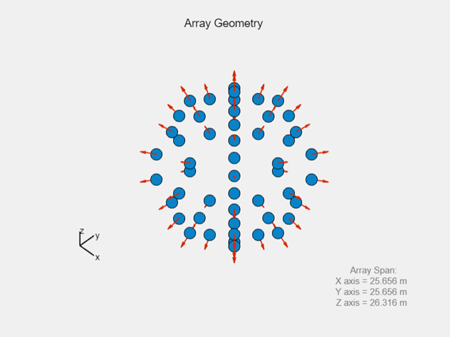

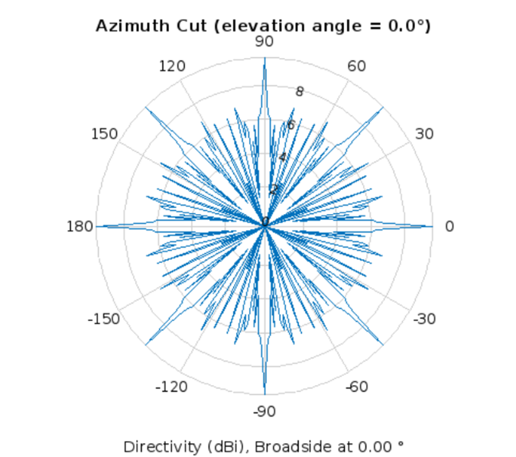

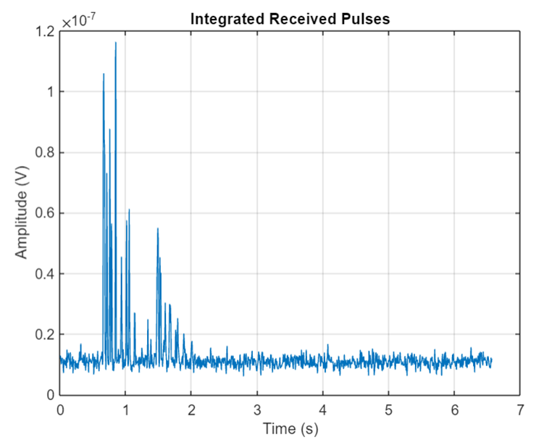

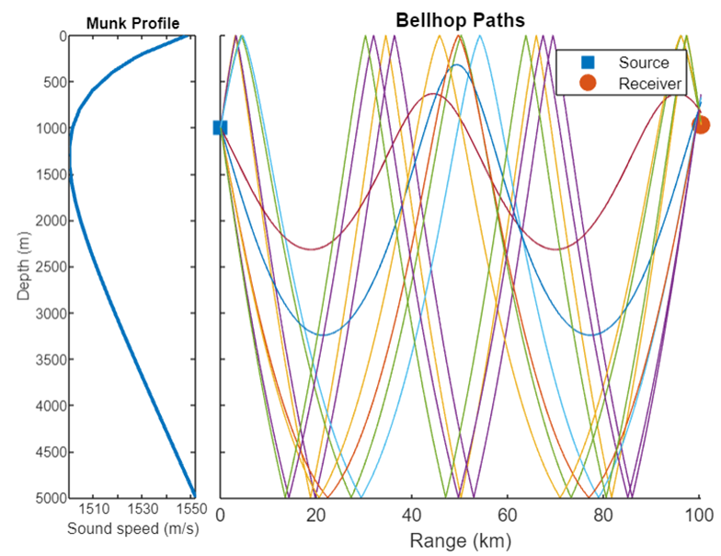

For this scenario, there are two direct paths with no interface reflections, and eight paths with reflections at both the top and bottom surfaces. The sound speed in the channel is lowest at approximately 1250 meters in depth, and increases towards the top and bottom of the channel, to a maximum of 1550 meters/second.

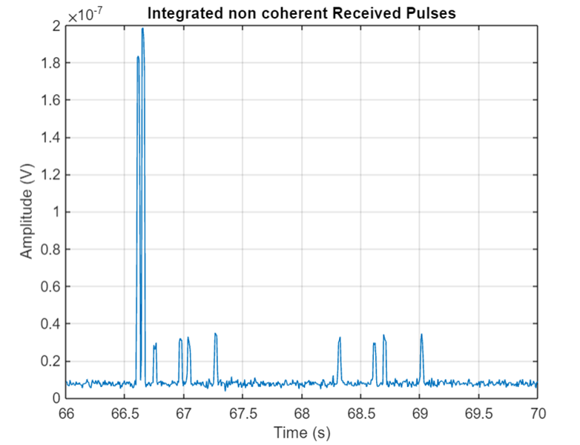Create a new channel and receiver to use with data from Bellhop.

The transmitted pulses appear as peaks in the response. Note that the two direct paths, which have no interface reflections, arrive first and have the highest amplitude. In comparing the direct path received pulses, the second pulse to arrive has the higher amplitude of the two, indicating a shorter propagation distance. The longer delay time for the shorter path can be explained by the fact that it propagates through the slowest part of the channel. The remaining pulses have reduced amplitude compared to the direct paths due to multiple reflections at the channel bottom, each contributing to the loss.

**INFERENCE:**

* In the bellhop simulation it can be observed that there are two direct paths with no interface reflections, and eight paths with reflections at both the top and bottom surfaces. The sound speed in the channel is lowest at approximately 1250 meters in depth, and increases towards the top and bottom of the channel, to a maximum of 1550 meters/second. The transmitted pulses appear as peaks in the response. Note that the two direct paths, which have no interface reflections, arrive first and have the highest amplitude. In comparing the direct path received pulses, the second pulse to arrive has the higher amplitude of the two, indicating a shorter propagation distance. The longer delay time for the shorter path can be explained by the fact that it propagates through the slowest part of the channel. The remaining pulses have reduced amplitude compared to the direct paths due to multiple reflections at the channel bottom, each contributing to the loss.
* Therefore, acoustic pulses were transmitted and received in shallow-water and deep- water environments. Using a rectangular waveform, an active sonar system detected two well-separated targets in shallow water.

# DETECTOR PERFORMANCE ANALYSIS USING ROC CURVES

**METHODOLOGY:**

**Single pulse detection:**

* With input SNR value, we can calculate the Pd and Pfa values that a linear or square-law detector can achieve using a single pulse.
* Set the Pd value if you have an SNR value of 8 dB and the requirements dictate a Pfa value of at most 1%.
* We can use the rocsnr function to calculate the Pd and Pfa values and then determine what value of Pd corresponds to Pfa = 0.01. Note that by default the rocsnr function assumes coherent detection.
* In the plot, select the data cursor button in the toolbar (or in the Tools menu) and then select the SNR = 8 dB curve at the point where Pd = 0.9 to verify that Pfa is approximately 0.01.

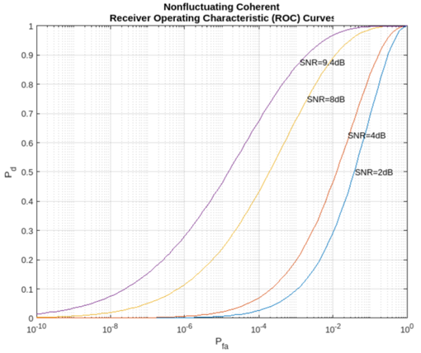

**Multiple Pulse Detection**

* One way to improve detector performance is to average over several pulses.
* This is particularly useful in cases where the signal of interest is known and occurs in additive complex white noise.
* Although this still applies to both linear and square-law detectors, the result for square-law detectors could be off by about 0.2 dB.
* Analyse the performance by assuming an SNR of 8 dB and averaging over two pulses.

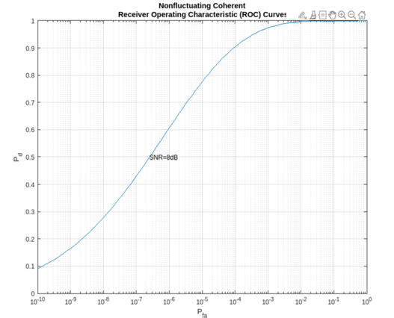

**Noncoherent Detector**

* To analyse the performance of a detector for the case where the signal is known except for the phase, you can specify a noncoherent detector.
* Using the same SNR values as before, analyse the performance of a noncoherent detector.
* Focus on the ROC curve corresponding to an SNR of 8 dB.
* By inspecting the graph with the data cursor, you can see that to achieve a probability of detection of 0.9, we must tolerate a false-alarm probability of up to 0.05.
* Without using phase information, you will need a higher SNR to achieve the same Pd for a given Pfa.
* For noncoherent linear detectors, use Albersheim's equation to determine what value of SNR will achieve the desired Pd and Pfa.
* Plotting the ROC curve for the SNR value approximated by Albersheim's equation, you can see that the detector will achieve Pd = 0.9 and Pfa = 0.01.
* Note that the Albersheim's technique applies only to noncoherent detectors.

